Sync any Brookfield Public School’s calendar with your Google account and phone

Great news! You can now add the BPS district calendar or any of the school calendars to your Google account and view them on your phone. It is automatically updated as events are added and changed, and you can receive notifications about upcoming events.

To be able to do this you will need a Google/Gmail account.

Here’s how:

- Go to the BPS website, www.brookfieldps.org
- Below slideshow, click on the calendar tab to view the calendar.

Note: If you would like to choose another available calendar, click on View All Calendars, then choose the desired calendar from the list.

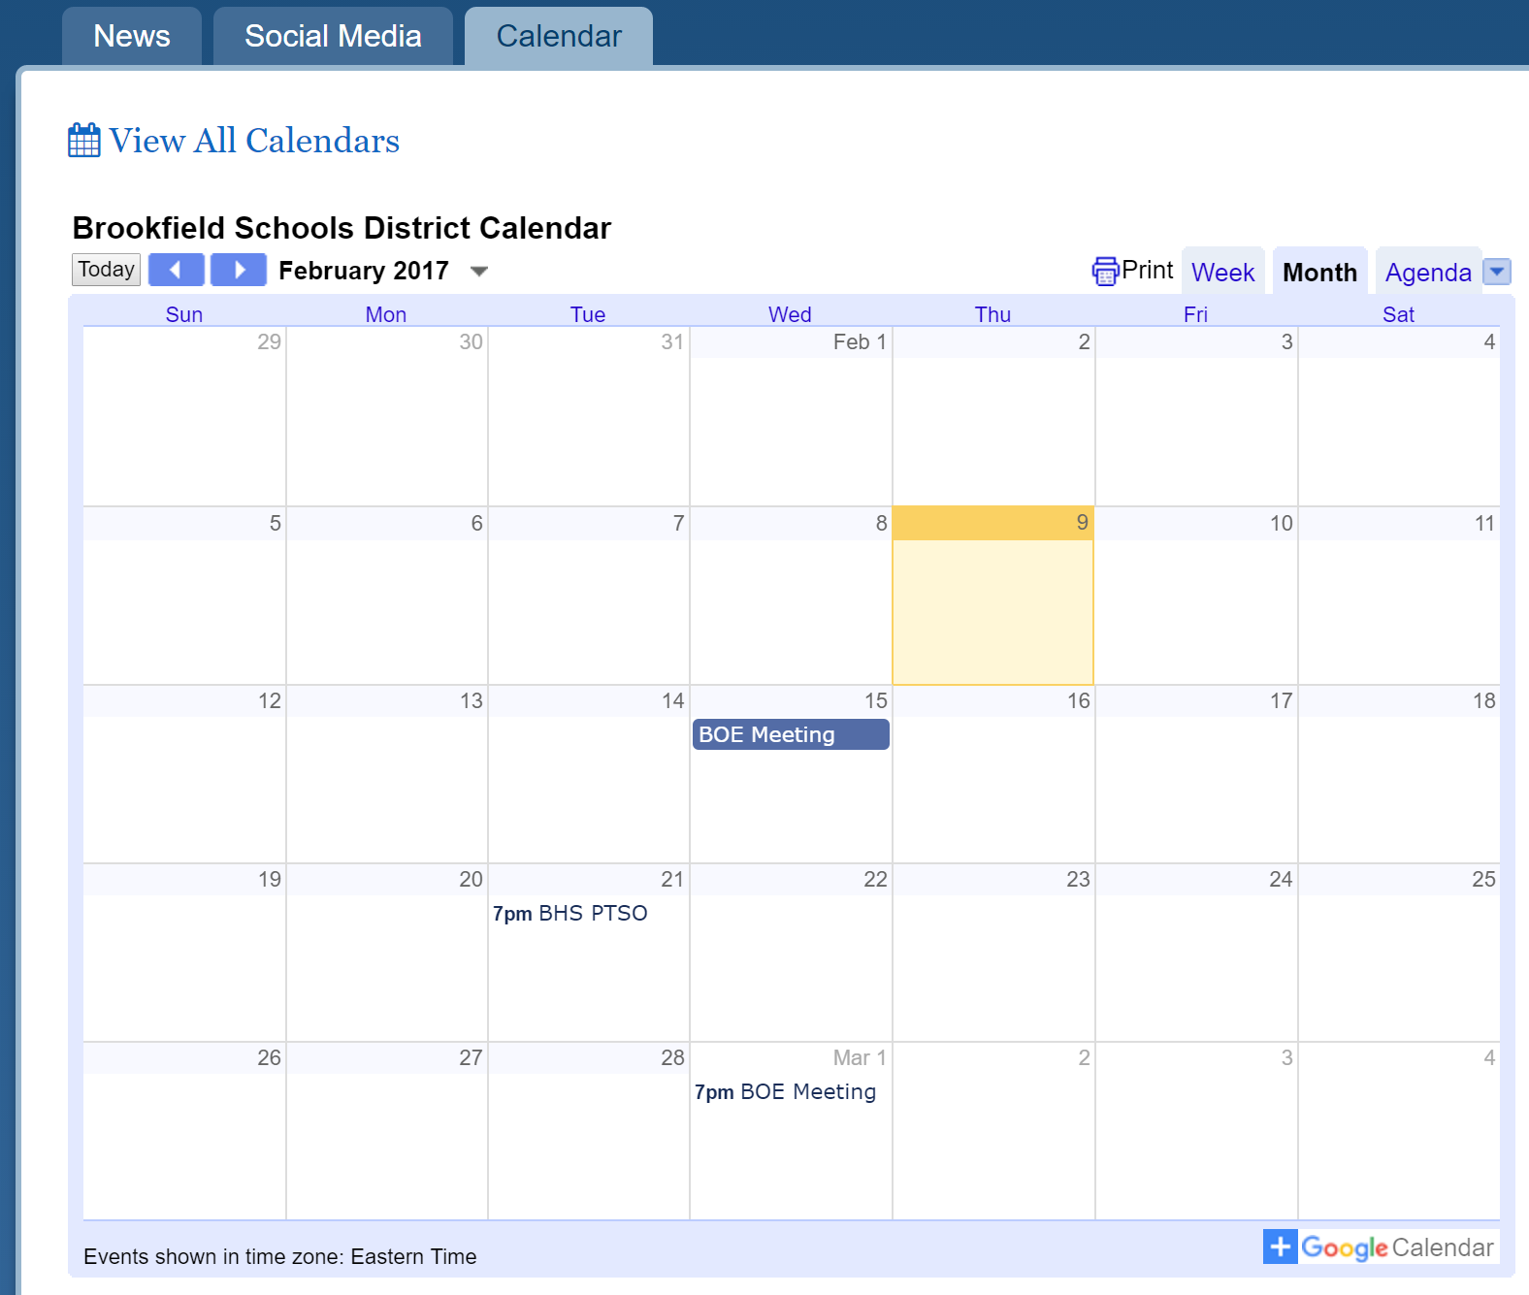

- Click on the + Google Calendar logo at the bottom right of the selected calendar.

- A new window will appear prompting you to log into your Google/Gmail account.

- After logging In you will be asked if you want to add the selected calendar. Choose Yes, add this calendar

- The selected calendar will then become part of your calendar list on the left side. You can change the color of the calendar, hide/unhide it, set notifications, and more.

